**DSLAB-03**

**Task1 A**

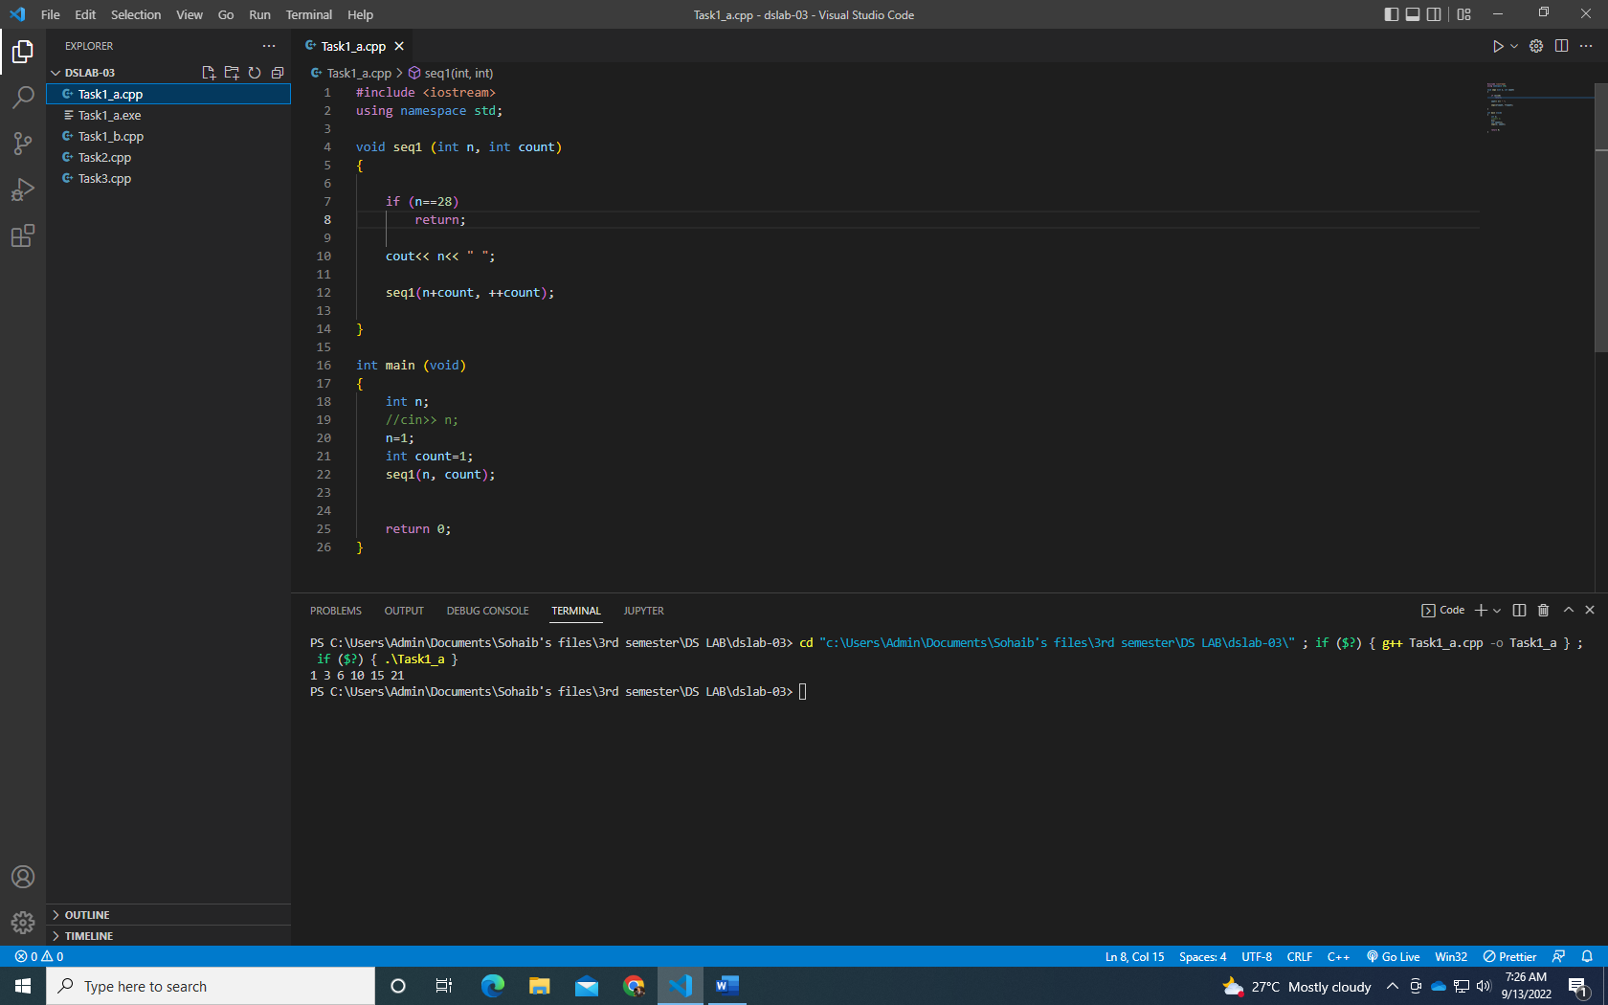

**Task 1 b**

**Task 2**

**Task 3**

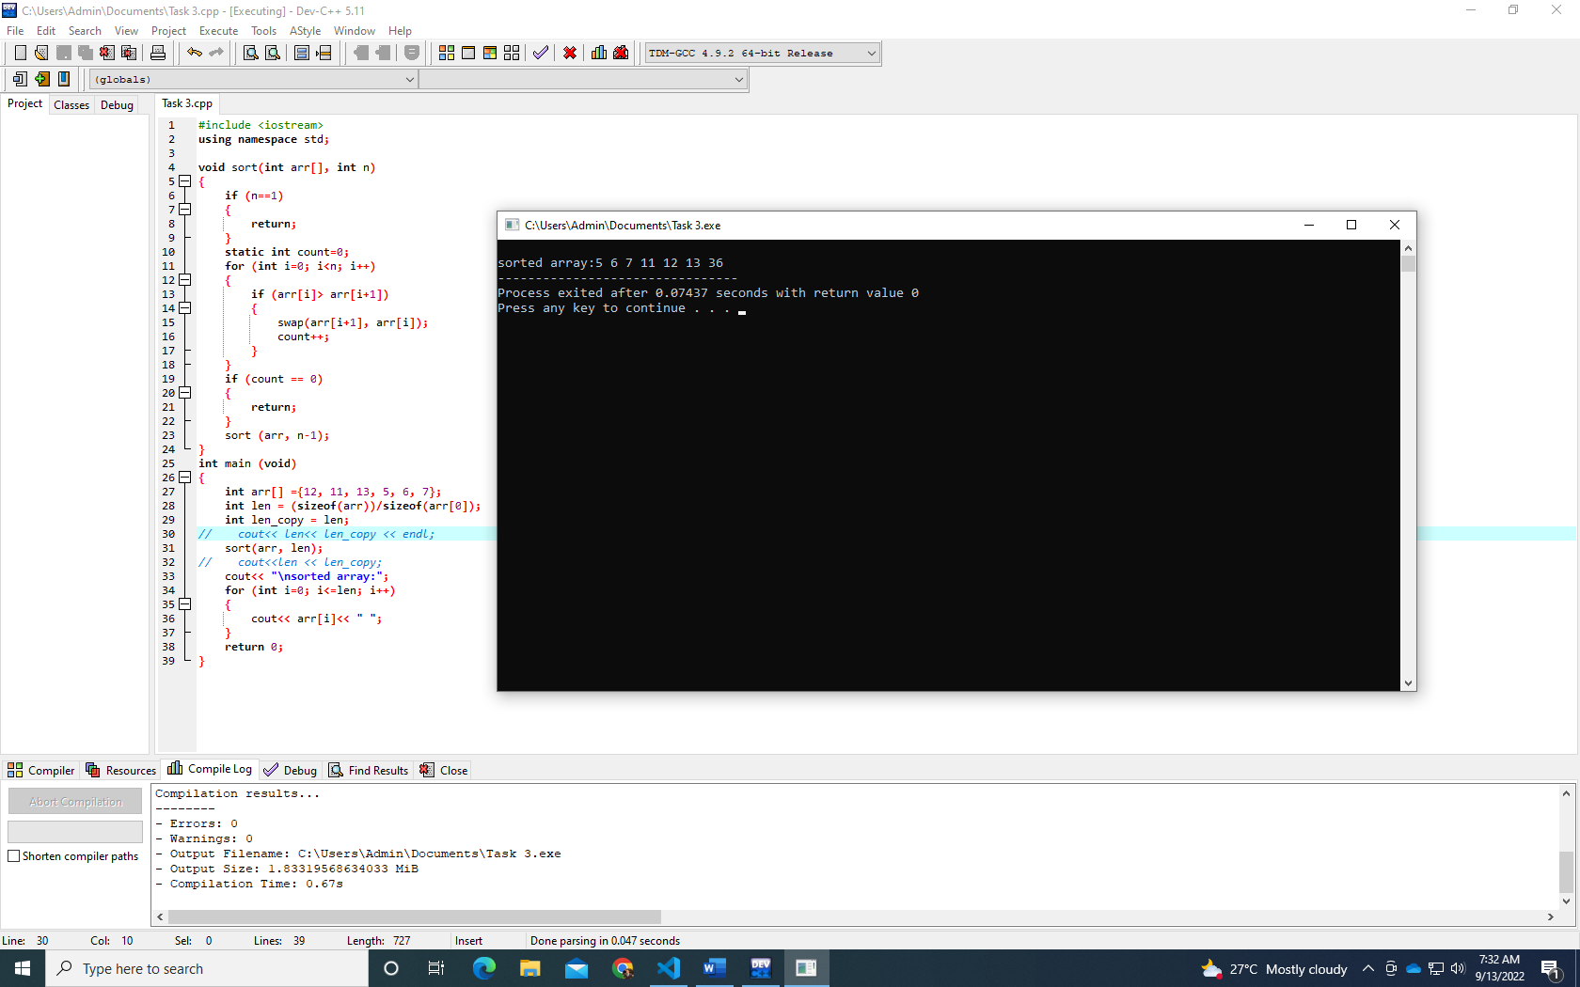

**Task 5**

